2dF CANopen Hardware Simulator –software specification.
Reference Documents 1
1 Introduction 1
2 Existing 2dF hardware configuration. 2
3 Existing 2dF Robot software configuration. 2
3.1 Computer systems used: 3
3.2 DRAMA Tasks 4
4 Notes on hardware and interfaces 5
4.1 PMAC Interfaces 5
4.2 Camera Interfaces 6
4.3 Digitial I/O 7
4.4 NVRAM 7
5 Notes on the 2dF Robot Task Structure 7
5.1 Action data structures 7
5.2 Threading 9
5.3 64 Bit machines 9
6 Software support to simulator – initial specification. 9
6.1 CML access from multiple DRAMA tasks. 10
7 Proposed Jobs for Knave and Varlet – Stage 1. 10
8 Stage 2 11

Reference Documents
[RD1] 2dF Robot Commands, Tony Farrell, 21-Feb-2017
[RD2] 2dFsim Hardware Interface, Apr-2017 (this version is a draft only)
[RD3] AAO Programming standards, Tony Farrell, 27-May-2016.

Introduction
The AAT is building a hardware simulator of the 2dF robot system. This simulator is intended to be a clone of the 2dF gripper gantry and is intended to help develop new mechanical, electronic and software components for 2dF.
As of December 2016, a working X/Y gantry exists. The theta mechanism exists and will soon be installed. Development is underway on the gripper.
The first aim of this hardware simulator is to help transition 2dF from PMAC control to CANopen hardware control via the CML library. This will also necessitate moving from VxWorks to a Linux based computer. The exact location of the Linux computer has not been determined but that is not a problem as the CANopen system can be connected via CAN over Ethernet devices.
Existing AAO software must be modified to support this new hardware solution and it may be implemented piecemeal. Details TBD. It is very important that the very many hard-learnt lessons for running 2dF, which are embedded in the existing software, are not lost and that 2dF be kept working during this period unless prior arrangements are made with AAO management for downtime.

Existing 2dF hardware configuration.
The 2dF hardware has evolved over 20 years. The current configuration is (roughly)
- A VME system with CPUs running VxWorks 5.2
- A digital I/O system.
- 2 PMAC motion controller cards.
  - PMACs also have control of some digital I/O.
- Frame grabbers used for the robotic system cameras.
- RS232 interfaces used to communicate with ADC and Calibration Lamp hardware
- The VME system has 2 VxWorks CPUs used as follows:
  - 2dFSys (system boot, ADC Task, Calibration Task)
  - 2dFPos (2dF Robot system)
- Back-illumination control (via I/O system and the 2dF Positioner Back-Illumination control interface (AAO-EL-HERMES-037-HW-TN)
- 1Mb of Non-volatile memory (NVRAM).

Existing 2dF Robot software configuration.
The 2dF software is a large and complex system that has evolved over some 25 years. Figure 1, below, shows the structure of the Robot Software component of the 2dF software and related components.
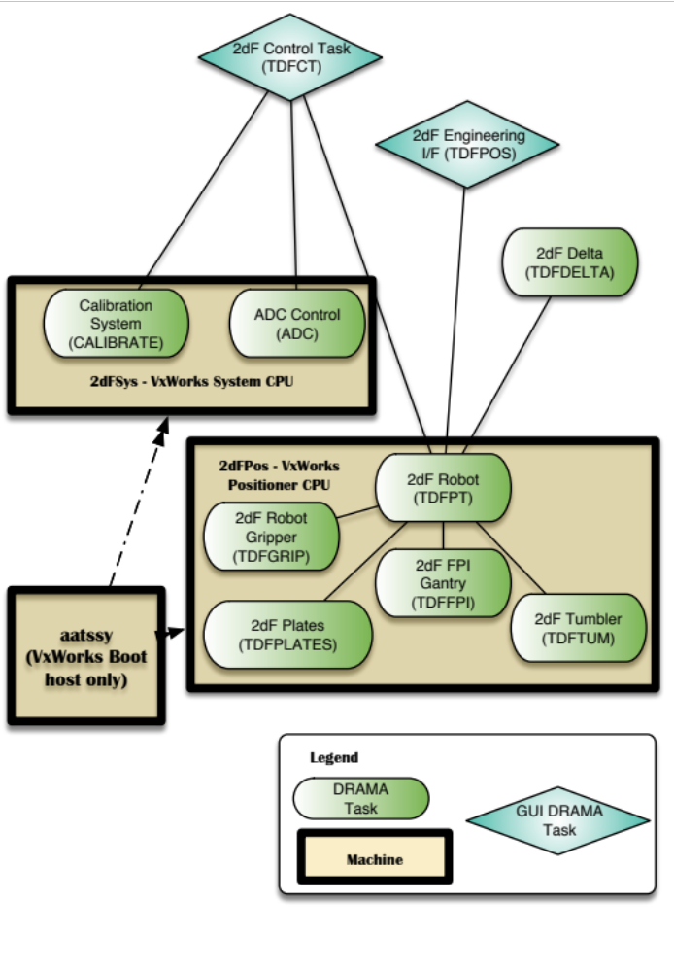
Figure 1: 2dF Robot and related tasks and machines

Computer systems used:
4 Computer systems are involved in the robot system
Hostname | Use
aatssy | In the run-time system, used only to boot the VxWorks CPUs.  Is also the machine on which the VxWorks software must be built.
aatlxy (or aatlxx or equivalent) | This is the machine on which the control task (TDFCT), Engineering Interface and delta task run. It is currently a Linux machine but other Unix based machines have been and could be used. It only needs a network connection to the VxWorks machine.`
2dFSys | The VxWorks system CPU. This CPU is connected to the wider AAT network directly. It provides network services to the 2dFPos.  It runs the ADC and Calibration tasks and hence must have access to the RS232 ports used by these tasks.
2dFPos | The VxWorks positioner CPU. This does not have a direct network connection but uses VxWorks VME Backplane networking to communicate via 2dFSys.  The actual robot tasks run on this machine, with the exception of the delta task and engineering GUI task.

DRAMA Tasks
Task | ACMM | Description
TDFCT | 2dFctrlTask | This is the overall 2dF control task. The positioner related systems are just a small part of what it controls – it also controls the spectrographs, CCD systems and Telescope via other DRAMA tasks.  In normal observing, the 2dF control task will start all other tasks and will implement synchronisation and interlocking.
TDFPOS | 2dFeng | The 2dF robot engineering interface – also used as the positioner mimic. The 2dF robot software can be started and run from this interface, which is normal during engineering operations.
TDFPT | 2dFpt | The main 2dF robot control task. This task does not control the hardware directly (except for some minor I/O). It uses the other tasks (TDFGRIP, TDFFPI, TDFLATES and TDFTUM) to control the robot hardware. This task is the task with the full picture of what is happening or must happen. For example, it knows where each is, where as the gripper task, which moves gives, is only concerned with x/y values of a single move.  It is this task that has control of the NVRAM system.
TDFGRIP | 2dFgrip | The task that controls the robot gripper gantry. This task controls the X/Y/Z/Theta and Gripper of the gripper gantry, and the gripper camera frame grabber. It also controls the back illumination system.
TDFFPI | 2dFfpi | This task controls the robot FPI gantry. It controls the X/Y motions FPI robot camera (not the sky camera which it carries- that has totally independent control).
TDFPLATES | 2dFplates | This task controls the 2dF plate rotators and the fiducial illumination.
TDFTUM | 2dFtum | This task controls the 2dF plate tumbler.
TDFDELTA | 2dFdelta | This task computes the set of moves required to move from one 2dF fibre configuration to another – the “delta” operation.  Since this is a compute intensive task, and the VxWorks CPUs are very slow by modern standards (40MHz), the delta task runs on the same machine as the control task. It is expected this separation will not be required when we move all tasks to Linux.
ADC | 2dFadc | This task controls the 2dF Atmospheric Dispersion corrector, via a RS232 interface.  This task can be updated for a different interface and moved off the VME system independently of the robot system.
CALIBRATE | 2dFcalibrate | This task controls the 2dF calibration lamp system, via a RS232 interface.  This task can be moved off the VME system independently of the robot system.

Notes on hardware and interfaces
Some notes on the various hardware interfaces.

PMAC Interfaces
There are two PMAC cards. PMAC 0 is used to control the gripper and the tumbler. PMAC 1 controls the FPI and plate rotators. A locking system at the level of the TDFPT task ensures only one task is talking to a particular PMAC at any one time.
The library found in the ACMM sub-system 2dFpmac implements the interface to PMAC. The PMAC system provides a register (port), into which commands are written, and a dual-ported RAM (DPR) scheme that allows command parameters to be written and status to be obtained efficiently (rather then via the slower command interface).
For example, to command an axis, the required parameters for the command will be written to particular locations in DPR. The command will then be issued. When it is complete, status will be read from other locations in DPR. The PMAC software maps variables used by the PMAC code to DPR locations, after which the use of DPR is transparent to the PMAC code. The file 2dFpmac/tdFpmacDPR.h defines the layout of the DPR. The file 2dFpmac/Notes/pmac.notes is a summary of the software and how to use it.
Documents in the 2dFrobotSWDocs ACMM sub-system, in particular, pmac.doc and pmac-vme.doc define the use of PMAC and the interface in detail (but have probably not been updated for a long time)/
Each of the robot tasks has their own interface layer for PMAC. For the gripper task, these are the files tdFgripPMAC.c (C functions), tdFgripPMACcmd.h (defines each of the commands to be sent) and tdFgripPMAC.h (macros giving PMAC command indices in the table defined in tdFgripPMACcmd.h).
Functions in tdFgripPMAC.c are declared in tdFgrip.h. An approach that ensures these files are not built/included when building for CANopen would ensure all use of PMAC is quickly found.
The code that runs on the PMACs can be found in the 2dFpmacPLCs ACMM sub-system. It is hard work to understand but various members of the AAT Electronics group know it well.

Camera Interfaces
The existing gripper camera is controlled via the AAO GCAM interface. It uses the VFG frame grabber library; a call to VfgActivate(), within main(), enables that module. From then, images are normally taken using GCAM library functions. (E.g. GCamImage()). Some VFG library calls are made to modify the simulation being used, change camera modes, support the use of the over lay plane (used to draw the location of centroids on the video frame) and a few other features.
Replacement of the core functionality is easy – replace VfgActivate() by the equivalent GCAM interface activation function for a new camera. Replacement of other VFG library calls requires more thought.
Full details of the replacement system are TBD. Whilst there is considerable attraction in a full digital camera, there are various places where we take advantage of having a simple video feed available including the timing of the fibre back-illumination on-time. As a result, we may continue to use a video frame-grabber scheme.
As of October 2017, two monochrome Allied Vision Mako G-125 cameras have been ordered for this role. See: https://www.alliedvision.com/en/products/machine-vision-cameras/detail/Mako%20G/G-125.html.

Digitial I/O
2dF has two Digital I/O systems. There is the “PMAC I/O system” and the “VME I/O” system. These are based on the same underlying hardware.
The VME I/O system is accessed via routines in the 2dFutil library, file tdFposVmeIO.c. The bits are defined in 2dFutil/tdFiomaps.h. A look at that file will tell you the type of things that are available.
The PMAC I/O system is a series of bits used by PMAC, e.g. limits, brake control etc.
The new hardware will require a new Digital I/O interface, likely based on Beckoff field bus system. Can add modules as required. All optically isolated and with far more bits available then are currently available in 2dF.
Things such as brakes will be controlled via the CANopen servo drives, but explicit commands may be required, where as in the existing system this is hidden by PMAC.

NVRAM
The NVRAM system is used by the TDFPT task to maintain the locations of the fibres. Each time a fibre is moved, the NVRAM is updated. After a few minutes of positioning, or the completion of a fibre move sequence, the NVRAM contents are written to disk (files tdFconstantsDF.sds and tdFcurrentDF.sds). On each update to the NVRAM, the time of the update is recorded. This time is also written to the file.
On start-up of the system, the last update time of the NVRAM is compared to the time recorded in the file. If they differ, the user must decide what to do.
The main reason for the use of the NVRAM system is the poor performance of the system – it takes some seconds to write the file to disk (both CPU time and network file write time) and as a result, if done on every move, it would cost considerable time over the typical 600 fibre moves in the 2dF configuration.
In the 6dF system on the UKST, we did not have NVRAM, but it had a much faster CPU and local disk. As a result, we just wrote the file on every move. This approach is recommended for this upgrade when we move away from VxWorks.

Notes on the 2dF Robot Task Structure

Action data structures
The various robot tasks and associated libraries use a similar structure. This is quite different from most other AAO DRAMA Tasks. It provides some features of an Object Oriented interface written entirely in C. (Note – code to be run on VxWorks should remain C only – through C++ can be used to help implement the CANopen interface)
The approach uses the creation of a singularly linked list of pointers that enables
- Multiple levels of parameter structures to be passed between functions whilst:
  - Still maintaining function modularity.
  - Providing for clean deletion of all parameter structures with a minimum of kick handler functions.
An example is the best way to understand this. This example is from the implementation of the MEASURE_Z_HEIGHT action (2dFgrip/tdFgrip.c/ tdFgrip___MeasureZHgt()).
After validating all its parameters, this code does something common to many of the other actions, see below:
- dataMEAS_Z = tdFgripStructCreate(MEAS_Z_TYPE,status);
- if (dataMEAS_Z) {
- tdFgrip_MEAS_Ztype *MEAS_Zdata= dataMEAS_Z ->userData;
- MEAS_Zdata->x = x;
- MEAS_Zdata->y = y;
- MEAS_Zdata->theta = theta;
- dataMEAS_Z->usingLock = usingLock;
- dataMEAS_Z->check = check;
- DitsPutActData(dataMEAS_Z,status);
- DitsPutHandler(tdFgripMeasureZHeight,status);
- DitsPutKickHandler(tdFgripKick,status);
- DitsPutRequest(DITS_REQ_STAGE,status);
- }
At line #1, tdFgripStructCreate() is invoked with a particular code defined. If you look at its definition (file 2dFgrip/2dFgripStruct.c) you will see it allocates space for an item of type tdFgripDataType (regardless of the value of the first argument), and then creates a second item based on the value of the first argument, which it stores in the userData item of the tdFgripDataType item. That former gives us a common structure to pass around in a consistent manner, the later is data specific to what we are doing.
There is a pattern to variable names, dataMEAS_Z points to the tdFgripDataType item, whilst MEAS_Zdata is then set to point to the userData item of tdFgripDataType, the data specific to what we are doing.
In addition to the userData item, the tdFgripDataType structure has items related to interlocks and checks required, the type of the item stored in the “userData” field and a link field called “more”, used to create the list.
On return from tdFgripStructCreate(), the values specific to this operation are filled in and a reschedule via a DRAMA Stage operation (immediate reschedule) are arranged. The value returned by tdFgripStructCreate()is specified as the action specific data item. Then the DRAMA reschedule event occurs, the routine invoked (tdFgripMeasureZHeight()) uses the action data item to retrieve access:

- TDFGRIP_INTERNAL void tdFgripMeasureZHeight (
- StatusType *status)
- {
- tdFgripDataType *dataMEAS_Z = DitsGetActData();
- tdFgrip_MEAS_Ztype *MEAS_Zdata = dataMEAS_Z->userData;
- …
It then uses the tdFgrip_MEAS_Ztype item to maintain its internal status as it reschedules.
Each subsidiary operation performed as part of the implementation does a similar thing, but sets the “more” item of the new structure to the value dataMEAS_Z. A “handler” item is set to the address of the function tdFgripMeasureZHeight(), telling the subsidiary code where to come back to. On completion of the subsidiary component, the action data is again set back to dataMEAS_Z and tdFgripMeasureZHeight() is invoked again. Functions such as tdFgripMeasureZHeight() are run as state machines.
This allows code tiding up after a failure or kick to delete all malloced memory and other resources. It also allows reuse of the subsidiary operation code.
The approach is rather complex in place (C++ would have helped a lot), but does work very well.

Threading
Threads are NOT used in the system, as it exists. Each DRAMA task runs one thread of control. Threads will be needed in the new code as part of the openCML implementation. This may be hard to get right, as the structure may not be well suited to this.

64 Bit machines
The 2dF robot software is currently built on various 64 bit machines (both Mac and Linux) but the VxWorks implementation and the normal linux simulation build are both 32 bit. The 64 bit builds of the robot software currently do not run, with an error occurring on start up of the software.
This is believed to be a poor mapping between DRAMA parameters and the types used to represent them, most likely, a 32 bit value being read into a 64 bit long value. This is fixable and will hopefully be fixed soon, but is noted as, as of this date, it has not been fixed.

Software support to simulator – initial specification.
The initial aim of this project is to support implementation of the hardware simulation of the gripper gantry to the point of running being able to run 2dF engineering interface. The following jobs are required:
- Implementation of a CANopen “software” (CML) simulation of the hardware. The structure implemented must support the expansion of CANopen CML software simulation to the entire 2dF robot system as various components are moved to CANopen Control.
- Confirmation of the ability of the 2dF robot system to run largely in simulation, with one task (TDFGRIP) running for real. This will need to be tested as it hasn’t been done for some time. (Tony Farrell must do this).
- Design of the broad approach to implementation of the new hardware interfaces and how they are to be integrated into 2dF. Ideally, the approach should allow one code set that it can be built in CANopen mode or PMAC mode, through if this proves too hard, it may be necessary to branch the software.
- Implementation of the solution designed above in the 2dF gripper task to the point where the hardware is capable of moving fibres.
- Documentation of the design and code.
Note – basic control of the new X/Y axis is a priority – so that the hardware design can be confirmed, but the software design must ensure the above requirements are met.

CML access from multiple DRAMA tasks.
The new implementation will, in the long term, require access to CANopen devices via CML from multiple DRAMA tasks. This is potentially problematic. A possible solution to this is that a new DRAMA task is implemented which is responsible for interfacing all CANopen hardware. By careful design, this reduces the number of locks needed in the current system. Of particular note in the current system is how control of the plates fiducials during a gripper survey can lock out control of the FPI as the FPI and the fiducials are controlled via one PMAC. Any new hardware access task should probably have independent commands replacing each PMAC operation in the existing system, and should then be responsible for talking controlling access to the hardware.

Proposed Jobs for Knave and Varlet – Stage 1.

- Working with Tony Farrell, determine the right approach for the multiple DRAMA tasks of the 2dF robot system to talk to the new CANopen 2dFsim hardware.
- Implement a CANopen software simulation – supporting the Gripper Gantry (see [RD1]. Depending on the approach taken in #1, this may need to support expansion to the other 2dF devices, or may need to be clone-able such that equivalents for the other 2dF devices can be easily generated.
It must be possible to enable/disable simulation at the component level (as per HERMES), via a configuration file. Additionally, it must be possible to enable full simulation without modifying the configuration file (e.g. to support the full robot system being put into simulation). Details will depend on the results of #1.
- Implement a test driver DRAMA program that can exercise the Hardware or CANopen software simulation (e.g. selection Hardware or Software simulations based on configuration file – both modes must be supported).
- Confirm operation of #3 with the available 2dFsim Hardware (currently x/y axis only, Theta and Z are currently being integrated and should be operational by the time the for testing. Gripper is being built) and ensuring the CANopen simulation matches the behaviour of the software.
- All code to be written to AAO Software Standards ([RD3]) in C++11, and on completion will belong to the AAO
- Documentation of the interface developed in #2 above, including the simulation configuration file.
- Provide training to staff (including site staff) on the system, in particular, on how to add extra functions to the system (e.g. support new CanOPEN devices)

Stage 2
Details of stage 2 are still to be determined, but will likely involve one or more of the following:
- Adaption of the tdFgrip DRAMA task to use the new hardware interface, followed by confirmation the system will work with the 2dF Engineering interface.
- Adding of more hardware devices – e.g. expansion to run the gripper itself but may not yet be available in Stage 1.
- Adapting the tdFgrip DRAMA task to use the new fibre cameras which will be used with the new group. These are monochrome Allied Vision Mako G-125 cameras. https://www.alliedvision.com/en/products/machine-vision-cameras/detail/Mako%20G/G-125.html. This task requires the creation of an AAO GCAM interface to these cameras, and any modifications to tdFgrip to support a different format camera. Consideration of how to handle the lack of some features provided by the existing camera and framegrabber (e.g. overlay plane, before/after exposure notifications)

We could probably move to C++ if really needed, but not a modern version. GCC 2.95 is the latest compiler version we have available.
Branching of the low-level tasks (2dFgrip/2dFfpi/tdFtum/2dFplates) is probably acceptable as they are now very stable. Branching of the high level tasks should be avoided, as they are more likely to change can keeping the branch in synch will be hard.

